**Final Report**

**Capstone Project- The Battle of Neighbourhoods**

**Introduction**

New Delhi is an urban district located in the city of Delhi. New Delhi serves as the capital of India and the seat of all three branches of the Government of

India. The city itself has a population of 257,803. New Delhi is a cosmopolitan city due to the multi-ethnic and multi-cultural presence of the vast Indian bureaucracy and political system. The National Capital Region is a much larger entity comprising the entire NCT along with adjoining districts in neighbouring states. The official language of New Delhi and the one that is most widely spoken is Hindi. However, English is also spoken as a formal language within businesses and government agencies. New Delhi is the largest commercial city in northern India. It has an estimated net State Domestic

Product (FY 2010) of ₹1,595 billion (US$22 billion) in nominal terms and ₹6,800 billion (US$95 billion) in PPP terms. As of 2013, the per capita income of Delhi was Rs. 230000, second highest in India after Goa. GSDP in Delhi at the current prices for 2012–13 is estimated at Rs 3.88 trillion (short scale) against Rs 3.11 trillion in 2011–12. Connaught Place, one of North India's largest commercial and financial centres, is located in the northern part of New Delhi.

With its diverse culture, comes diverse food items. There are many restaurants in New Delhi City, each belonging to different categories like Chinese, Italian, French etc. So as part of this project, we will list and visualize all major parts of New Delhi City.

**Data Requirements**

New Delhi restaurants data that contains list Locality, restaurant name, rating along with their latitude and longitude. The data that we are going to need to help us make this project are:

1) Data source: Zomato kaggel dataset: https://www.kaggle.com/shrutimehta/zomatorestaurants-data

Description: This data set contains the required information and we will use this data set to explore various locality of New Delhi City. All the nearby places in each locality of new Delhi city will be listed and visualized.

2) Data source: Foursquare API: https://developer.foursquare.com/

Description: By using this API we will get all the exact coordinates of the venues in each neighbourhood.

**Approach**

1) Collect data from the already prepared dataset of zomato kaggel dataset.

2) Mark all nearby neighbourhoods with the help of Foursquare API.

3) Perform Data Filtering on the acquired random data.

4) Take an aggregate rating in order to solve the business problems.

5) List and Visualize the ranking of the restaurants according to the business problems.

**Methodology**

1. The first step is importing all the libraries

The 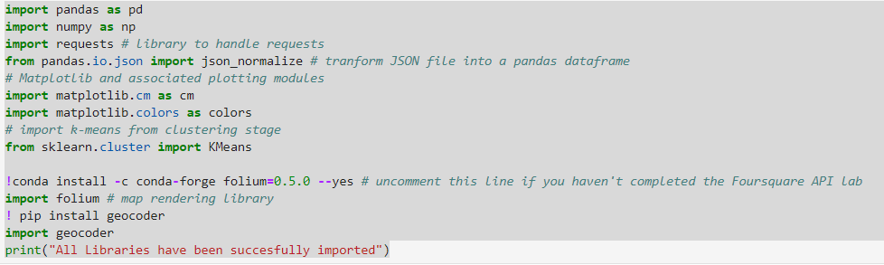

1. The zomato restaurants data file is read from the csv file

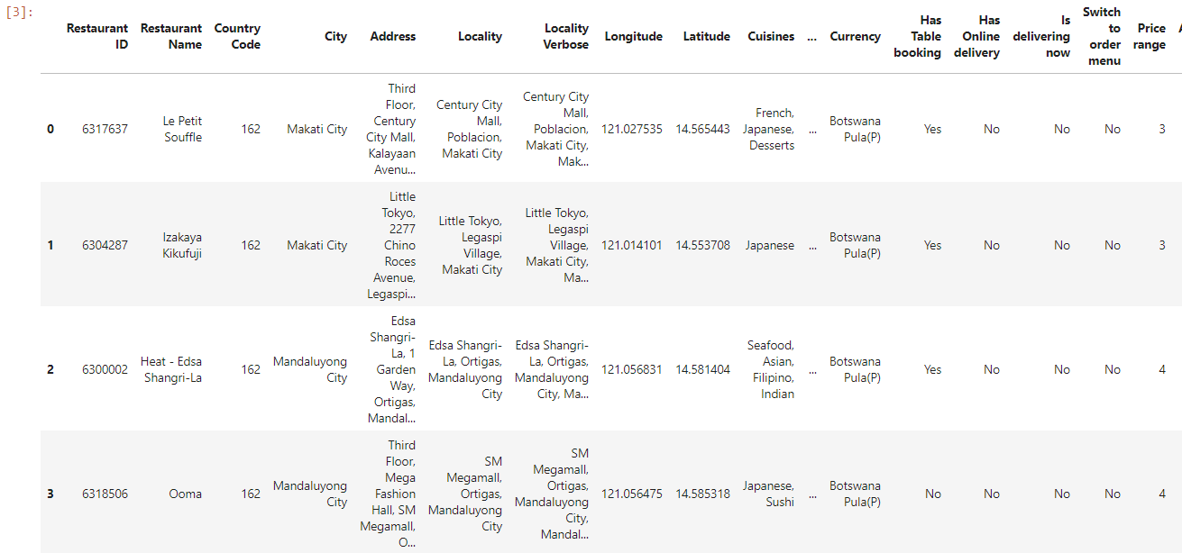

This is the dataset that we retrieve using the zomato.csv file.

1. The dataset obtained in this step is random and is not filtered for the purpose of our project that is listing the restaurants in in the city of New Delhi. We create a new dataframe named df_india

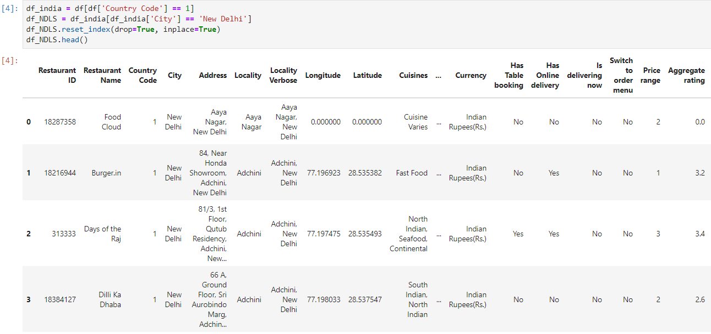

1. After obtaining the dataset data cleaning is done, all the unwanted rows and columns are removed.

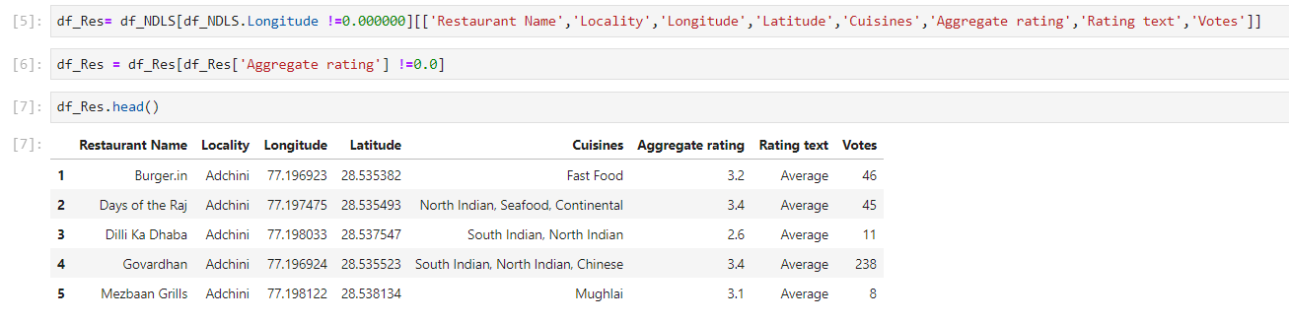

1. Once all the cleaning is done we plot a map to show the restaurant cluster

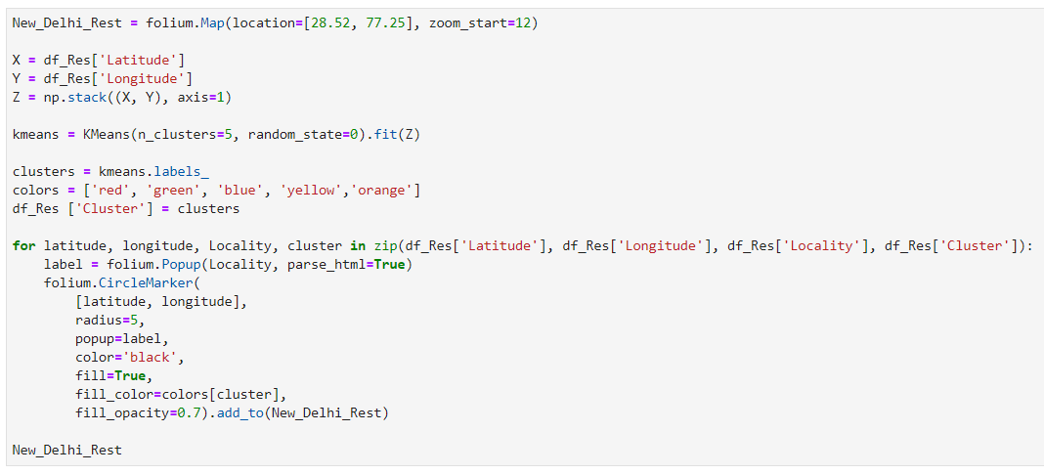

1. In order to answer all the problems stated in the business problems, we plot bar charts using the function bar (). Below are the six questions that are solved with the help of the bar charts.

* Which are the highest rated restaurants in New Delhi?

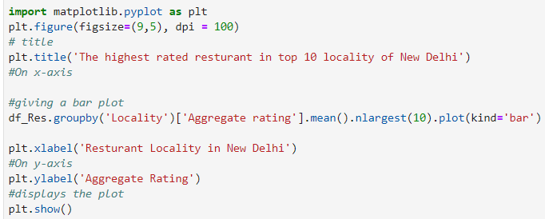

* Which is the lowest rated place in New Delhi?

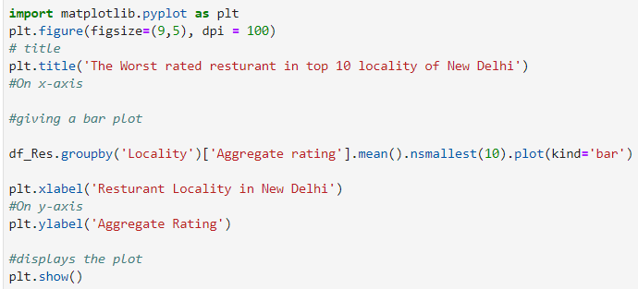

* Where would one find highest number of restaurants?

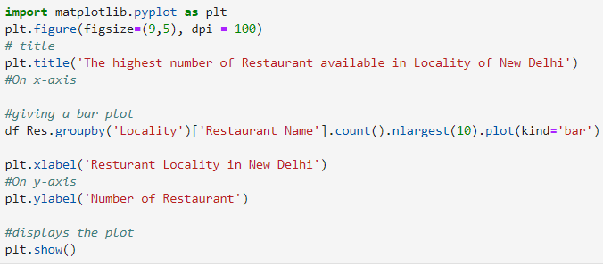

* Where would one find the least number of restaurants?

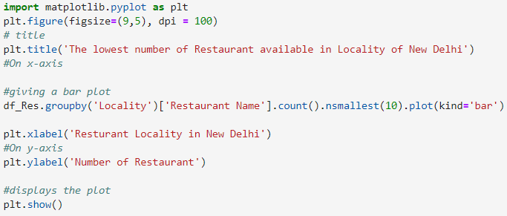

* What is the best locality for Chinese cuisine?

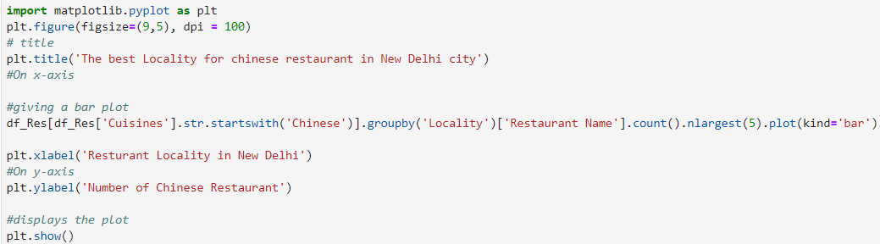

* Which is the best chines restaurant in New Delhi?

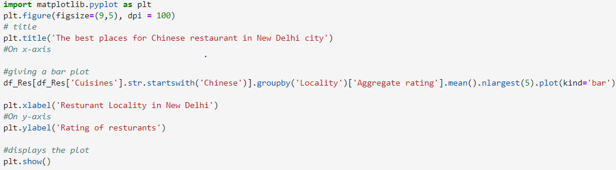

All the outputs will be displayed and answer to the all objectives of the project will be provided in the results and discussion section.

1. The next process that is performed in Data Transformation.

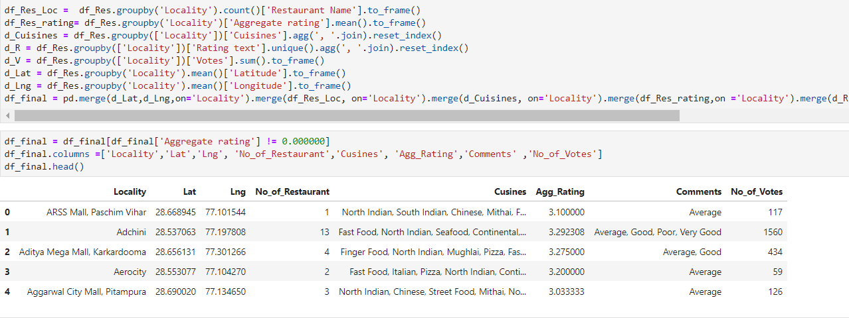

1. In order to get the exact latitudes and longitudes to plot the final choropleth map we use the foursquare API. In this step the foursquare credentials are used to access Foursquare API.
2. Then we create a function to repeat the same process to all locality in New Delhi.

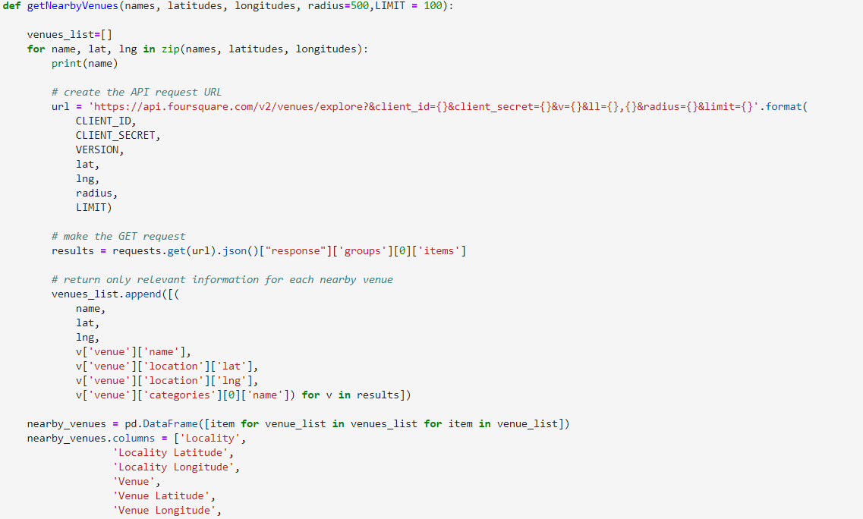

1. After this we do a deep search to find all the venues in New Delhi, we achieve by performing the following code

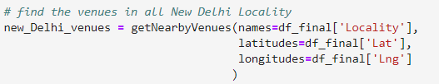

1. Finally, we analyse each locality

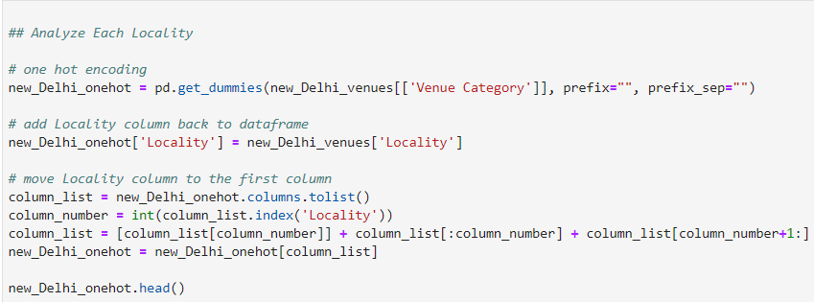

1. Cluster then locality restaurants using K-means clustering

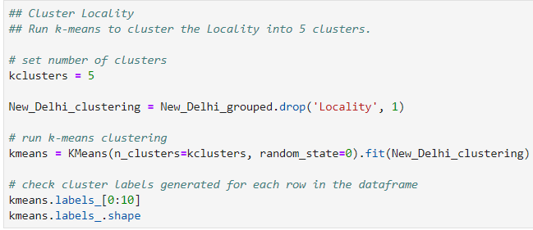

1. We add clustering labels

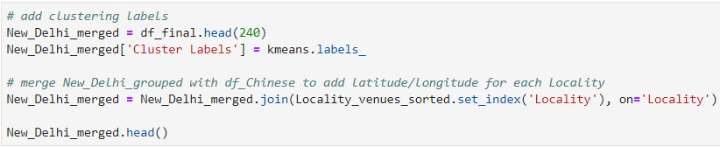

1. In the final step we plot the map

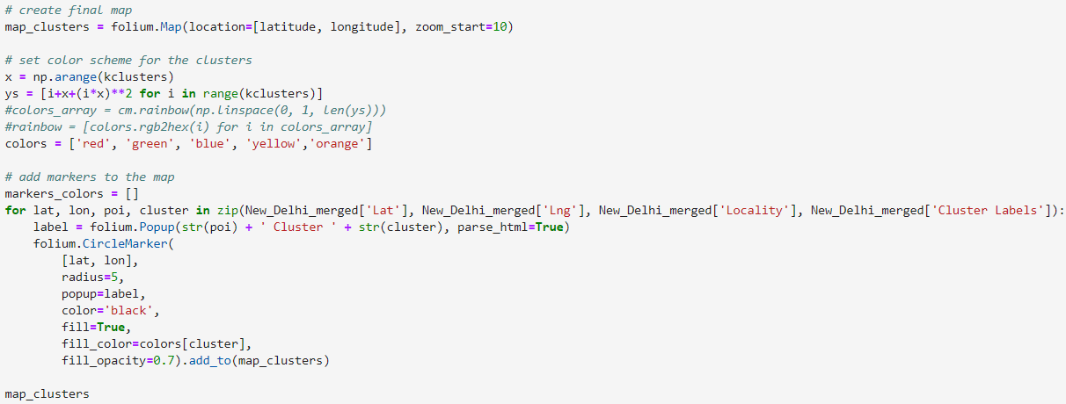

1. At the end, we examine all the clusters and determine the answers.

**Results & Discussions**

In this section we’ll discuss about all the outputs that have been obtained in the project and that will help us answer the business problems.

1. Where is the best rated restaurants present?

The graph below depicts the best rated restaurants

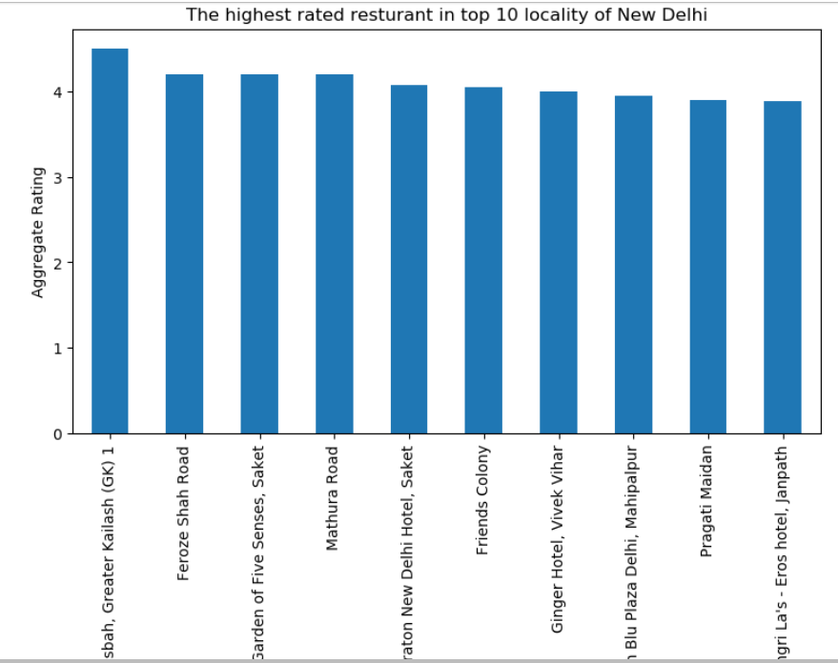

Result: As you can see Kasbah, Greater Kailash(GK) is the place for best rated restaurants.

1. Which place have the worst rated restaurants in New Delhi?

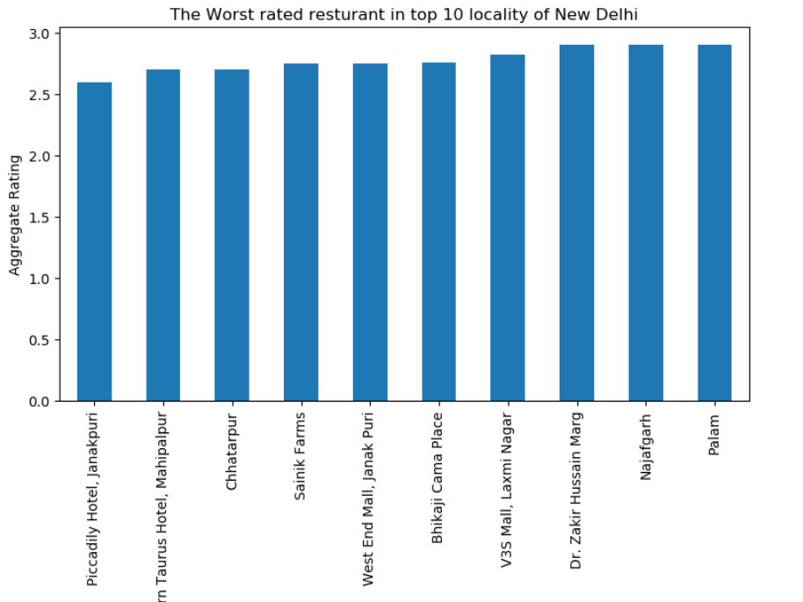

Result: As you can see Piccadilly Hotel, Janakpuri is the place for worst rated restaurants.

1. Where are the highest number of restaurants available?

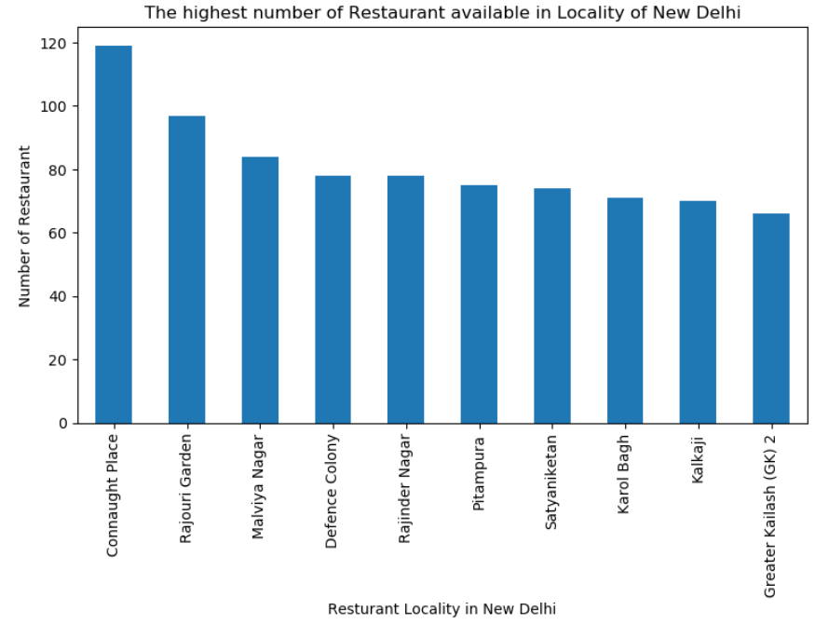

Result: As you can Connaught Place is the place which has highest number of restaurants.

1. Which place has the least number of restaurants in New Delhi?

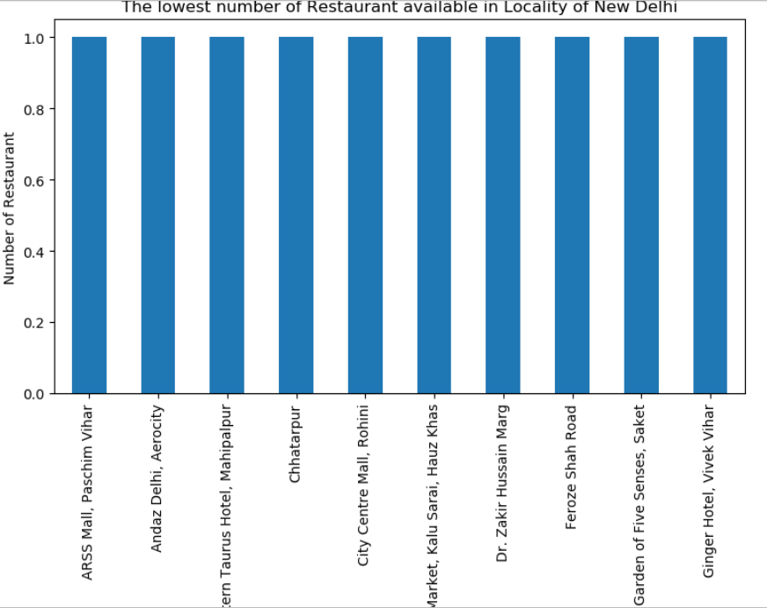

Result: As you can ARSS Mall, Paschim Vihar is the place which has least number of restaurants.

1. Which is the best locality for Chinese cuisine in New Delhi?

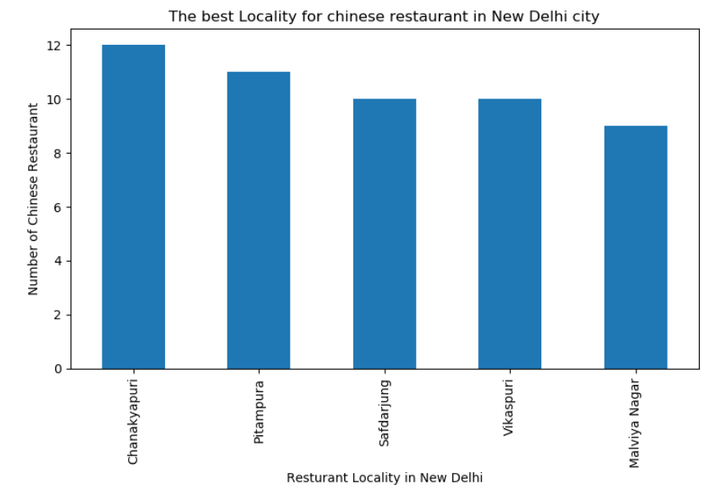

Result: As you can see Chanakyapuri is the best locality for Chinese cuisine.

1. Which is the best place for Chinese restaurants in New Delhi?

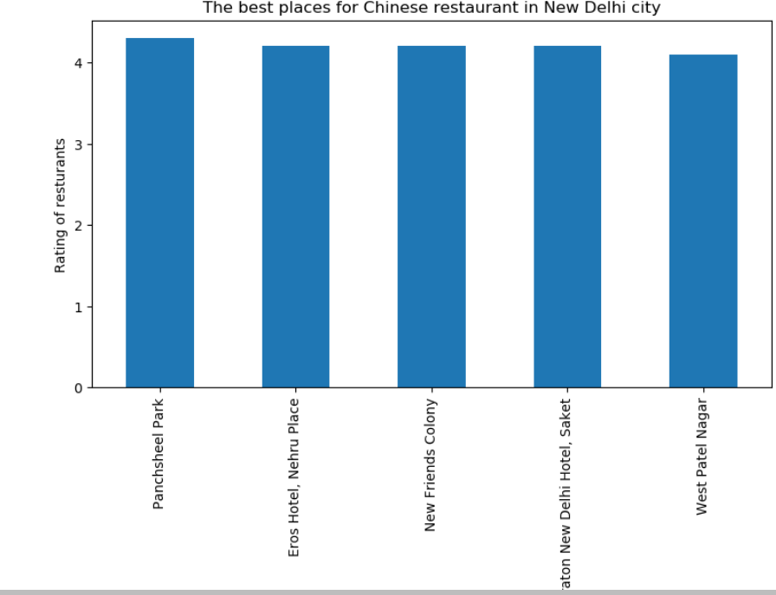

Result: As you can see Panchsheel Park has the best Chinese restaurants.

**Conclusion**

* **THE BEST RATED RESTAURANTS ARE AVAILABLE IN KASBAH, GREATER KAILASH(GK).**
* **THE WORST RATED RESTAURANTS IN DELHI ARE IN PICCADILY HOTEL, JANAKPURI.**
* **THE HIGHEST NUMBER OF RESTAURANTS ARE AVAILABLE IN CONNAUGHT PLACE.**
* **THE LOWEST NUMBER OF RESTAURANTS ARE AVAILABLE IN ARSS MALL.**
* **THE BEST LOCALITY FOR CHINESE RESTAURANT IS CHANAKYAPURI.**
* **THE BEST PLACE FOR CHINESE RESTAURANT IS PANCHSHEEL PARK.**